QUICK GUIDE
OPPOSING VIEWPOINTS IN CONTEXT/GLOBAL ISSUES

Follow this guide step-by-step and you’ll have mastered the basics of these two databases.

Step 1—START. Go to www.bhhslibrary.com, then Research&Tools—databases.
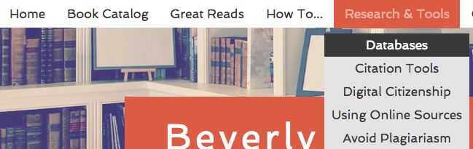

Step 2—Click on the Opposing Viewpoints icon. You only need the username and password if you are NOT on the BHHS campus.

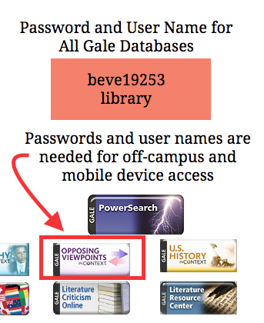

Step 3—SIGN IN. Sign into your Gmail first. THEN click “Sign in with Google” to create a free online account. The account means you can save your articles to an online folder that you can access at any time.

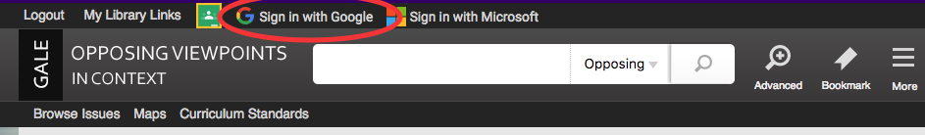

Step 4—You can tell you’re signed in when your first name appears at the top of the screen.
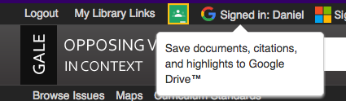

Step 5—2 ways to find issues: 1. Browse issues or 2. View All to see a complete list.

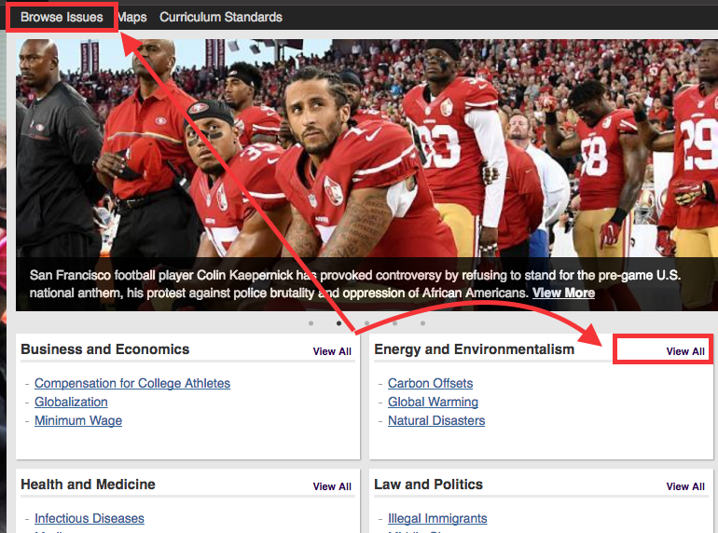

Step 6—Look at all issues covered if you need ideas on what to research. If an issue is listed, the chances are very good there’s plenty of research material.
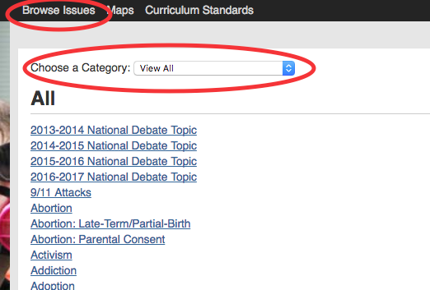

Step 7—You can also choose a category. DEBATERS: Note that National Debate Topics ARE listed on this database!

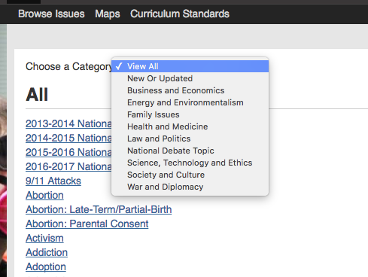

Step 8—You can search 2 databases at once (Global Issues and Opposing Viewpoints). For the rest of this worksheet, we’ll stick with Opposing Viewpoints.
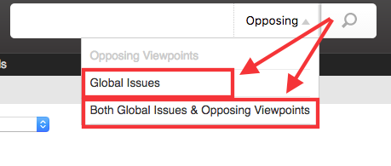
Step 9—The database will suggest search terms when you start typing in the search bar.

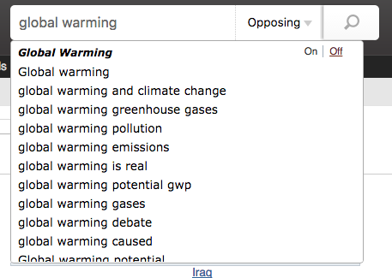

Step 10—Select GLOBAL WARMING as your topic. Note that the page for this topic shows an OVERVIEW (summary) of the issue and has a menu on the right-hand side. Navigate the article by using the menu (or just scroll down the page).

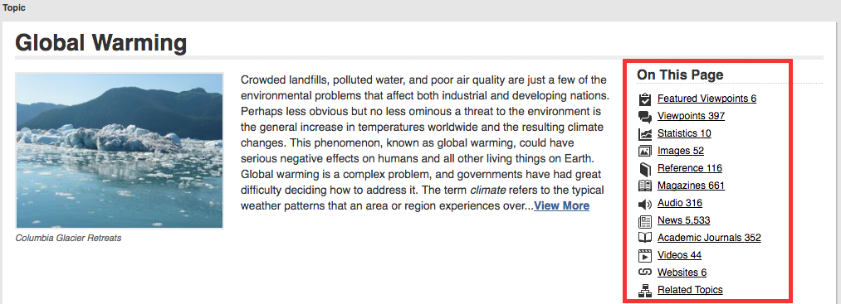

Step 11—Chose FEATURED VIEWPOINT with this title (in a box below)

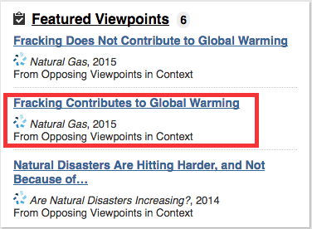

Step 12—Read the two boxed sections. The 1st section tells you about the person who wrote the viewpoint. The second section gives you questions to guide your reading. Note: If you click on the LISTEN button the computer will read the article to you!

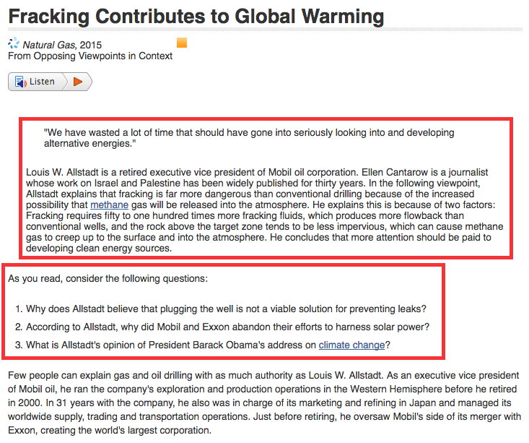

Step 13—The MOST IMPORTANT parts of the menu are outlined in BOXES below.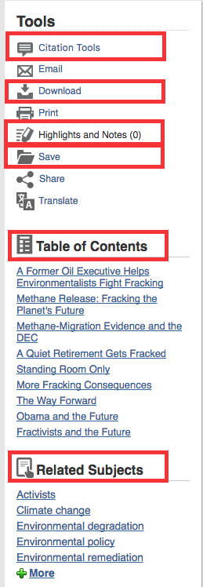
Click here to automatically cite your article!

Click here to download in PDF or to SAVE to GOOGLE DRIVE

Click here to add highlighting and/or notes

Click here to SAVE to your online account. The articles will save in your folder and will stay there until you remove them.

Use the Table of Contents to see an outline of the article and to navigate efficiently through the article.

Related Subjects give you more topics to research that are similar to “global warming”.

Don’t be afraid to explore these functions and the others that aren’t in boxes.

Step 14—LMITING YOUR SEARCH TO NEW ARTICLES.
Most research assignments will ask you to only look at sources published in the last 5 years. Here’s how to limit your search to only find those newer sources:

Click on the ADVANCED search button at the top of the screen.
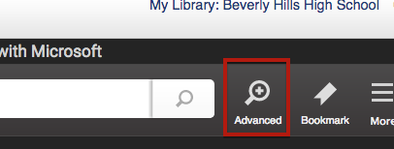

Enter your search term, limit the date, and select the Content Type.
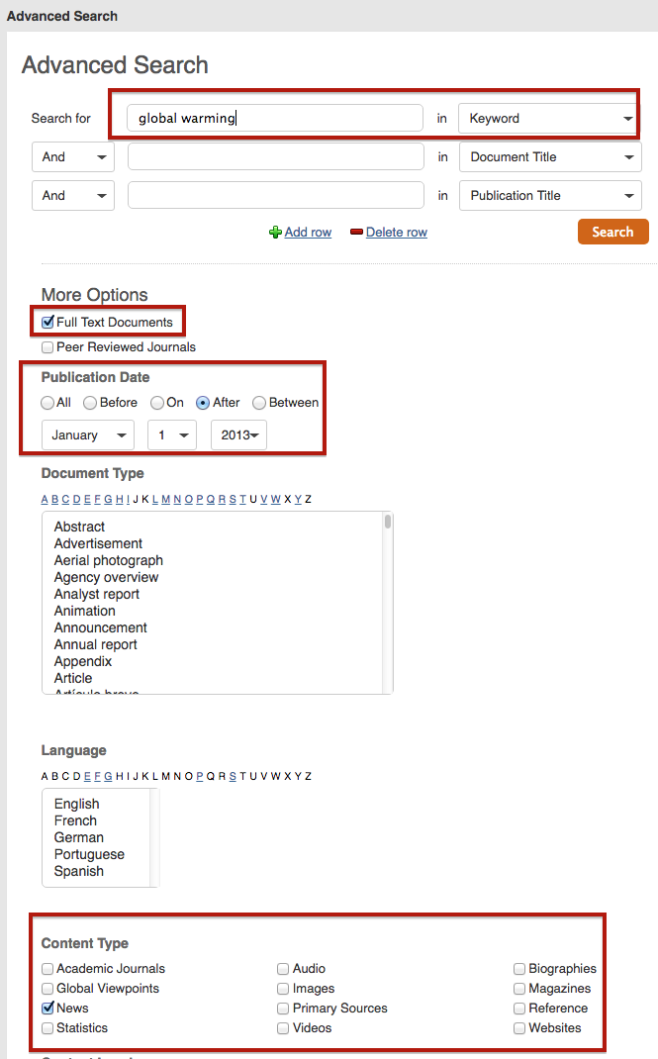

Step 15—Citing, Sharing and Saving Articles.

CITATION TOOLS button. Choose your citation format and Save to Google Drive.

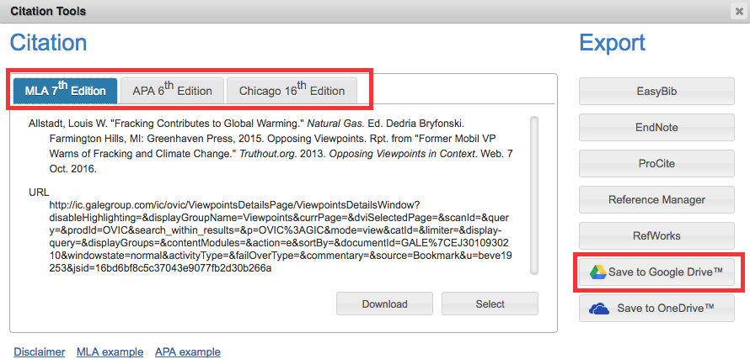

Step 16—There’s an EMAIL button in the menu. Click on it and fill in the blanks to send the article to yourself, a teacher, or your work partners. Send as an html link or as a PDF document.
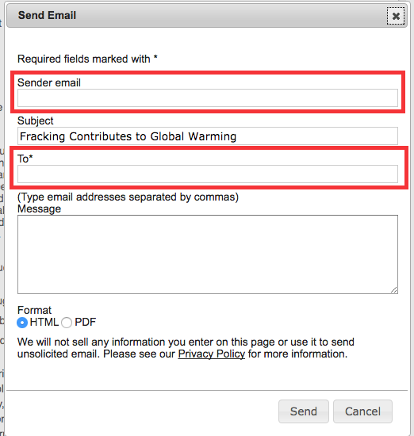

Step 16—Click on the DOWNLOAD button to SAVE to Google Drive!
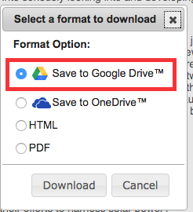

Step 17—When you click on the SAVE button in the menu, the article will show up as added in “My Folder”. Click on “My Folder” to see all the articles you saved. The articles stay in “My Folder” UNTIL YOU LOG OFF AND THEN THEY WILL DISAPPEAR. So you need to save them to Google Drive!

HOW TO SAVE ARTICLES FROM YOUR FOLDER TO GOOGLE DRIVE

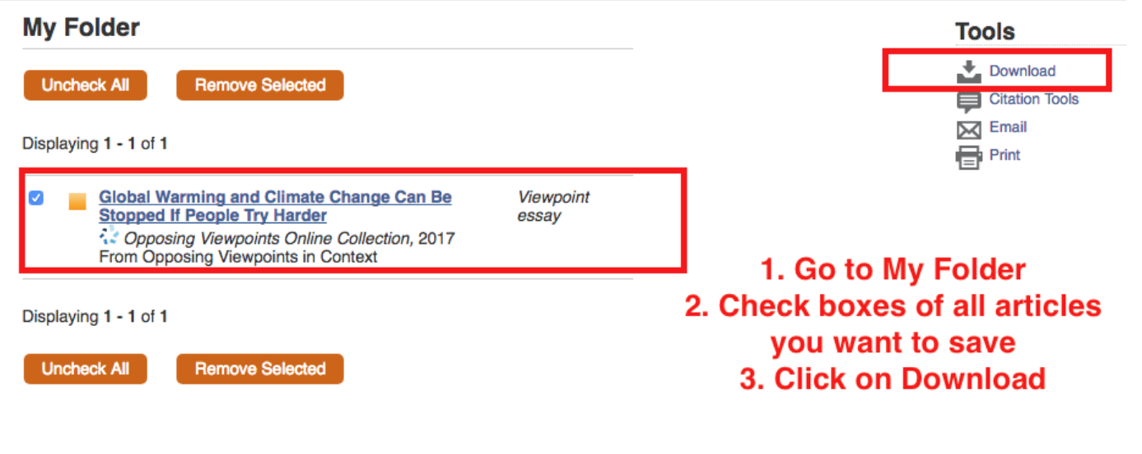

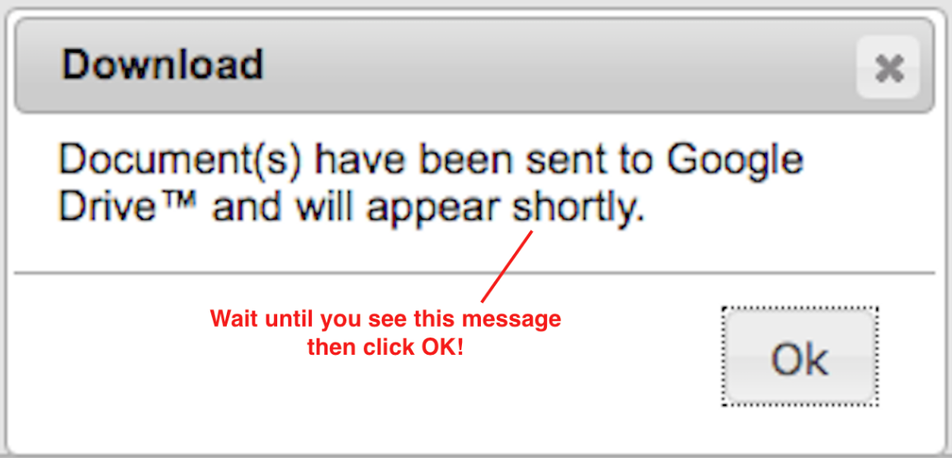

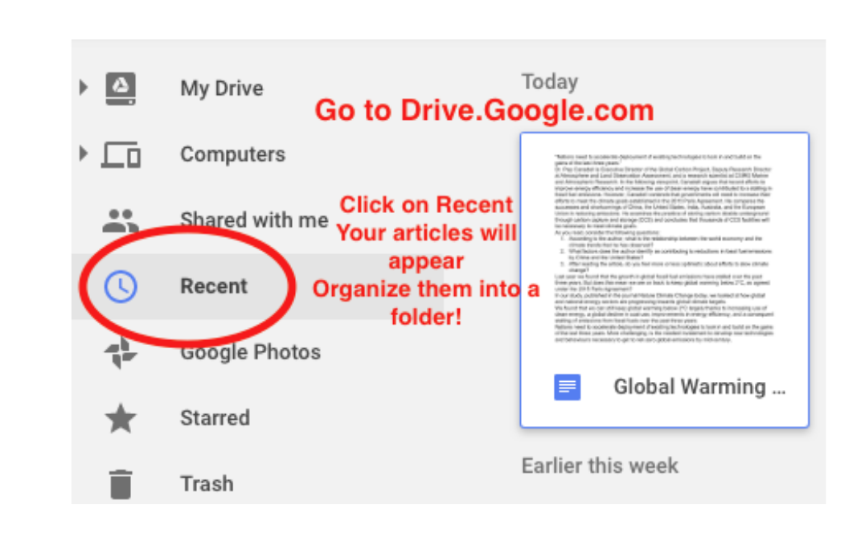

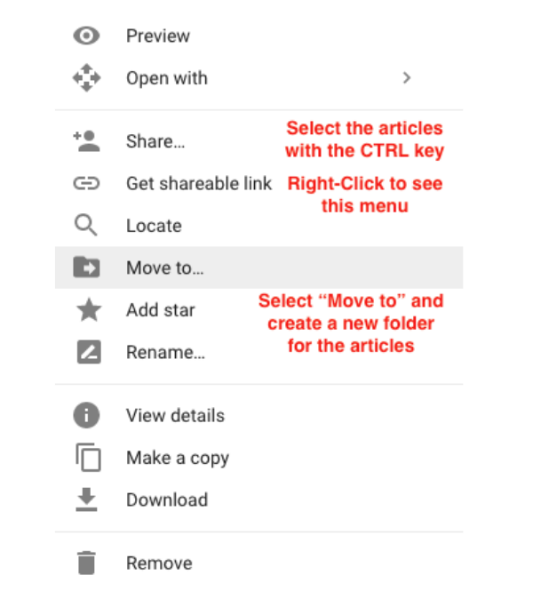
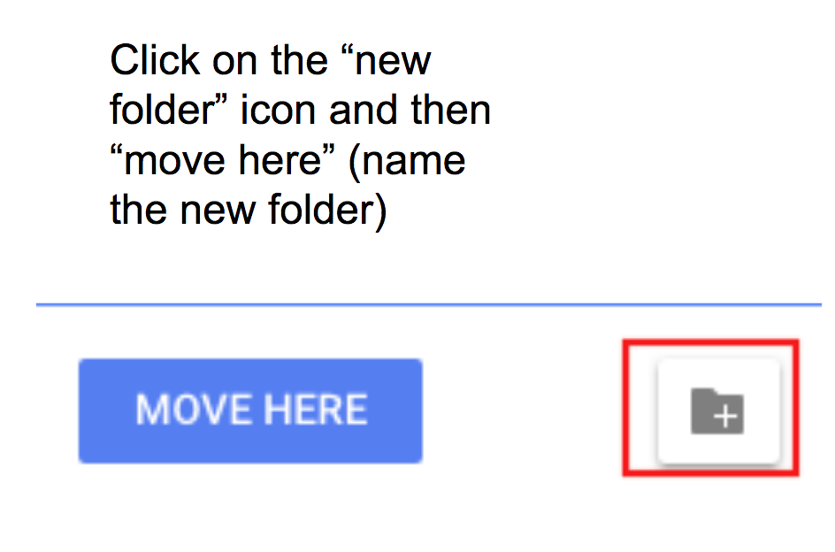

You can also add highlighting and notes to the article. Review all of your searches by clicking on Search History.

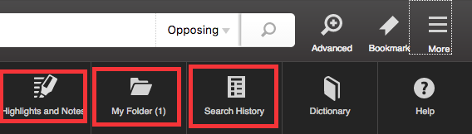

HOW TO SAVE TREES (making your assignment paperless) You can share ALL of the contents of your folder this way:

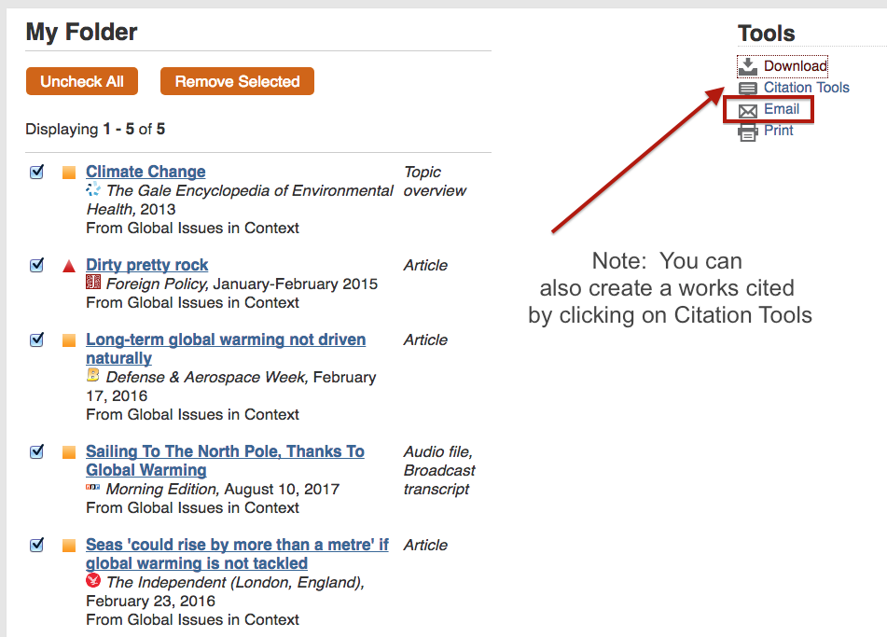

When you select the articles (you can select one, some, or all) and click EMAIL, you can send the entire article to someone:

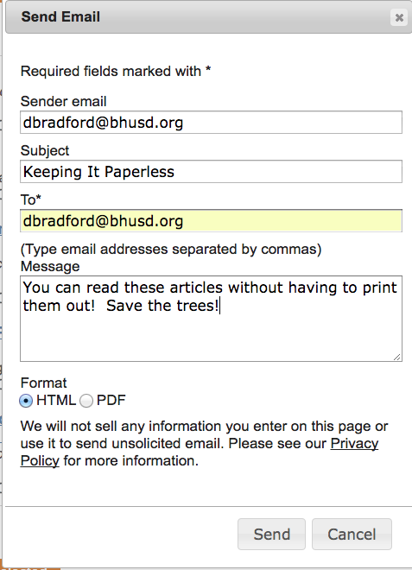
You can also select PRINT and then “print” (save) to Google Drive (make sure you’re signed into your Gmail account first). Then share the Google Drive folder!

Step 18—Highlighting and adding notes. Highlight by holding down your LEFT mouse key and dragging it across the text, then click HIGHLIGHT.
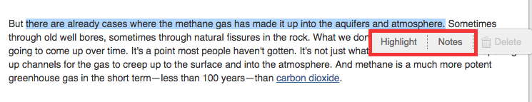

Step 19—Now choose the color of your highlight. The highlight remains until you click DELETE.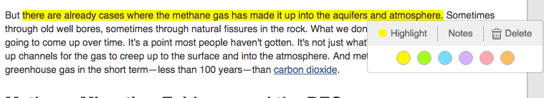

Step 20—Now click on NOTES for your highlighted text. Ask questions or comment on the material (can be shared with other people).

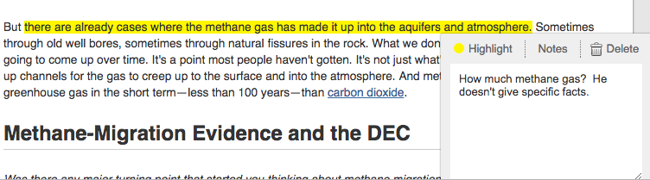

This has been an overview of the BASIC functions of this database. The GALE databases are all very similar so if you’ve learned how to search Opposing Viewpoints, your skills should transfer over to those other databases.

Remember: Use databases BEFORE Google! Databases are written by experts and are VERY trustworthy. Websites found through a Google search actually take MORE time because you have to evaluate each website and you have to search through a lot more results to get the information you need. So: Save time! Be accurate! Use a database!

