HOW TO SAVE ARTICLES FROM ANY GALE DATABASE TO GOOGLE DRIVE
IN SEVEN EASY STEPS

Step 1: Before searching a Gale database, sign into your Gmail in a separate tab. You can use your school Gmail account or personal Gmail account! Then click on Sign in with Google:
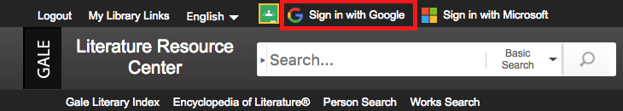

Step 2: You’ll know that you’re signed in when your name appears at the top of the screen.
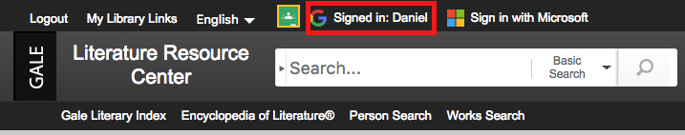
Step 3: When you find an article, click on SAVE by either clicking on the blue SAVE button or using the “Save to My Folder” or “Send to Google
Drive” option.
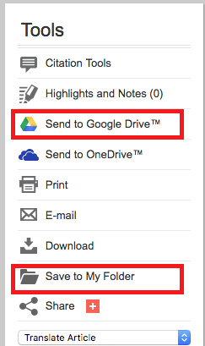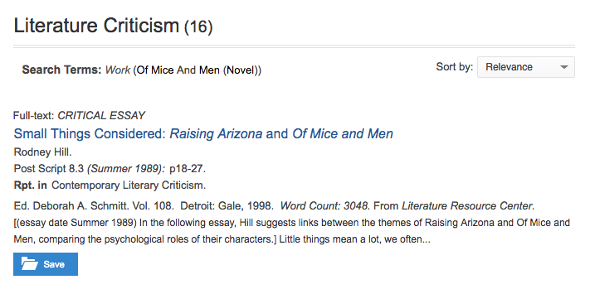

Step 4: Now go to MY FOLDER and click Send to Google Drive.
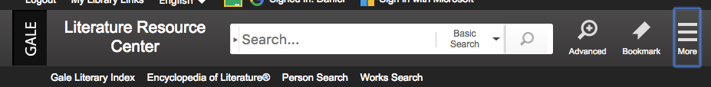
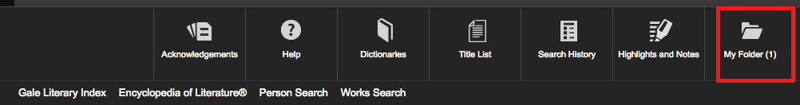
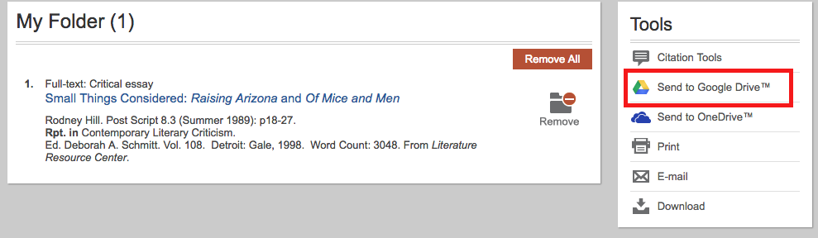

Step 5: You should see this message.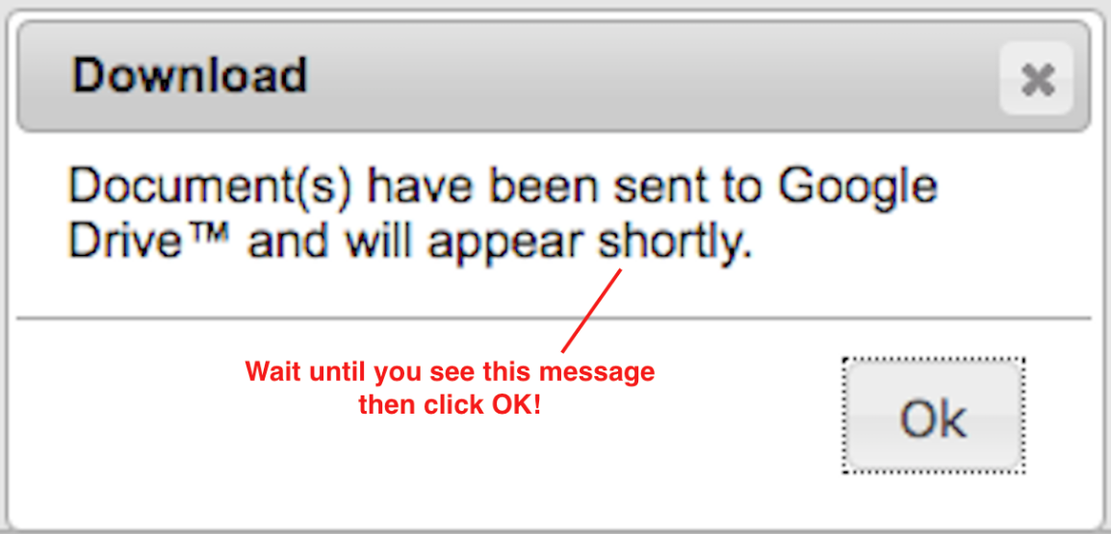
Step 6: Open drive.google.com and choose RECENT.

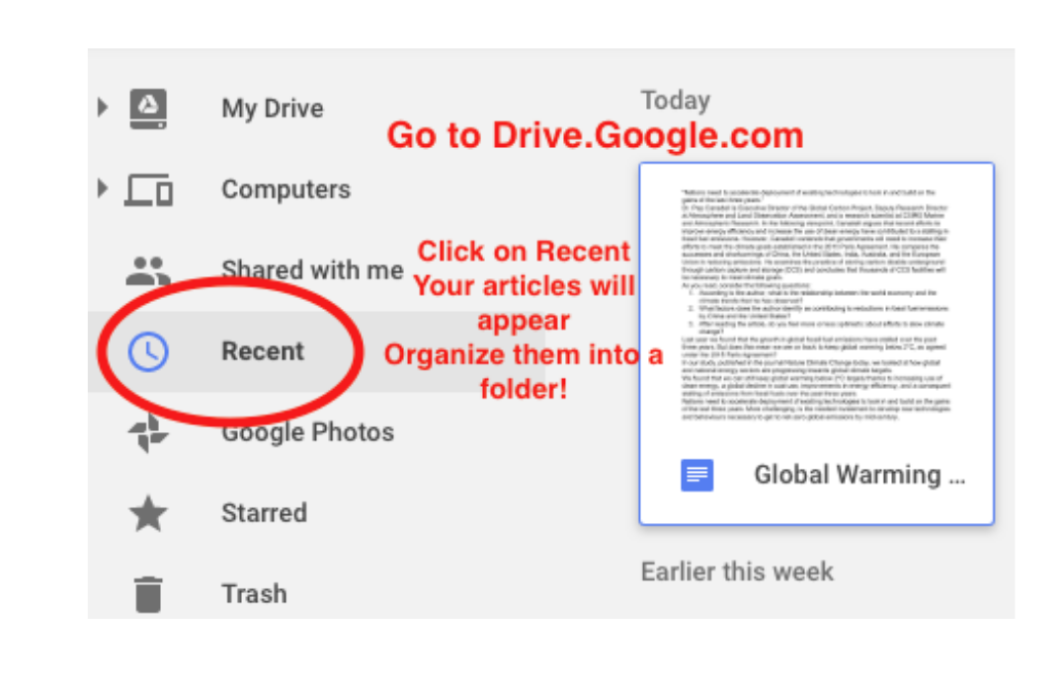

Step 7: Organize your research by moving your folders to a new file!

