QUICK GUIDE
WORLD HISTORY IN CONTEXT

Follow this guide step-by-step and you’ll have mastered the basics of these two databases.

Step 1—START. Go to www.bhhslibrary.com, then Research&Tools—databases.
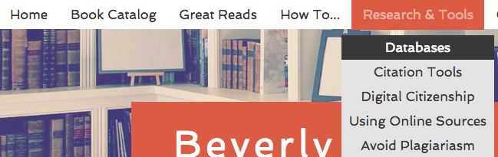

Step 2—Click on the World History in Context icon. You only need the username and password if you are NOT on the BHHS campus.

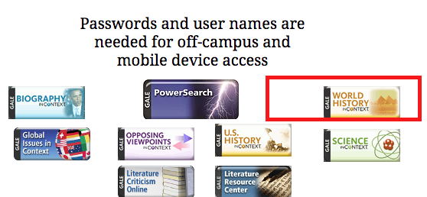

Step 3—SIGN IN. Sign in with your Google account to create a free online account. You’ll need this! (Sign into your Gmail first and then click “Sign in with Google”)

Step 4—You can tell you’re signed in when your first name appears at the top of the screen.
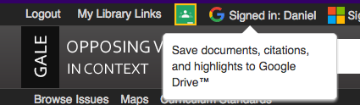

Step 5—2 ways to find information: 1. Browse Topics or 2. Search bar

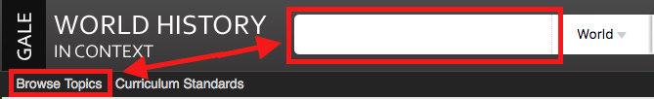
Step 6—Look at all issues covered if you need ideas on what to research.
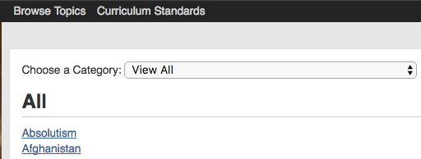

Step 7—Search the database by typing your search term into the bar. The main search term will be in boldfaced type.
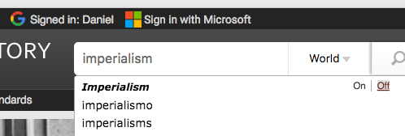
Step 8—The different types of documents for each topic are listed under the heading On This Page. If you’re looking for Primary Sources, for example, this topic has 20 Primary Sources listed.
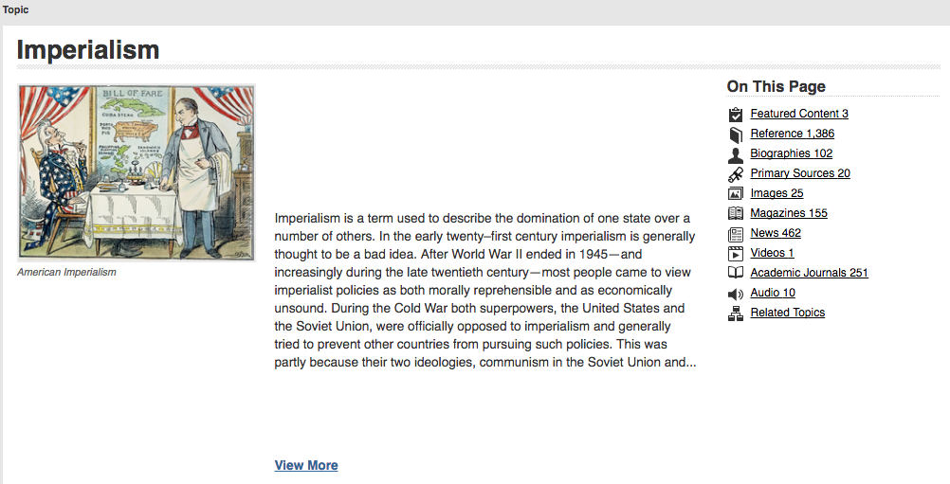
Step 9—If you want to search some more, use the Related Topics box to find articles that are similar:
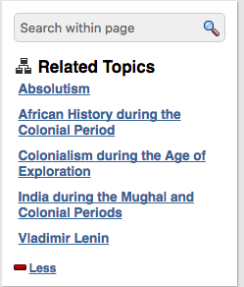

Step 10—Choose this article under “Featured Content” so we can explore how to save and how to cite articles!

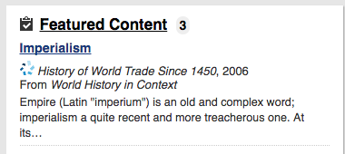

Step 11—Look at the Tools box on the right-hand side of the page. If you click on Citation Tools, it will cite the article for you. If you click on Email, it will email the article to you and your work partners. Save will save your article to an online folder that you can access ANY time. (Remember, you created an account in Step 3)

MOST IMPORTANT parts of the menu are outlined in BOXES below.
Click here to automatically cite your article!

Email your article(s) to yourself and to work partners!

Click here to download in PDF or to SAVE to GOOGLE DRIVE

Click here to add highlighting and/or notes

Click here to SAVE to your online account. WARNING! Upload to Google Drive BEFORE you log off—articles disappear when you log off!!!

Step 12—CITATION TOOLS button. Choose your citation format and Save to Google Drive.

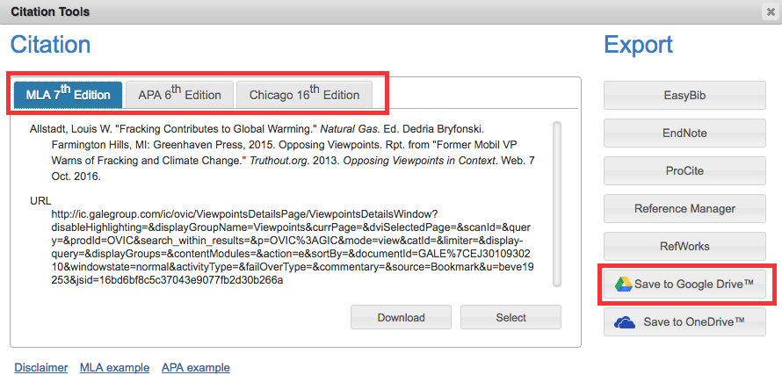

Step 13—There’s an EMAIL button in the menu. Click on it and fill in the blanks to send the article to yourself, a teacher, or your work partners. Send as an html link or as a PDF document.
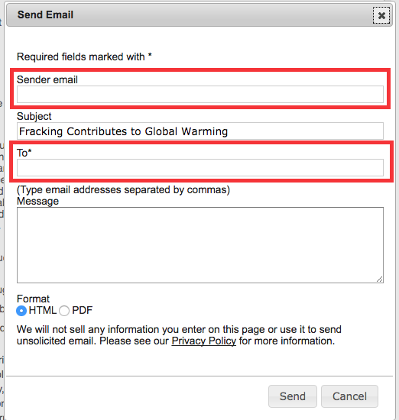

Step 14—Click on the DOWNLOAD button to SAVE to Google Drive!
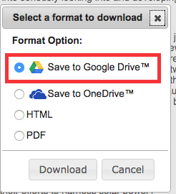

Step 15—When you click on the SAVE button in the menu, the article will show up as added in “My Folder”. Click on “My Folder” to see all the articles you saved. The articles stay in “My Folder” until you log off and then DISAPPEAR (save to Google Drive!)—See separate guide on how to organize your Google Drive folders.
You can also add highlighting and notes to the article. Review all of your searches by clicking on Search History.

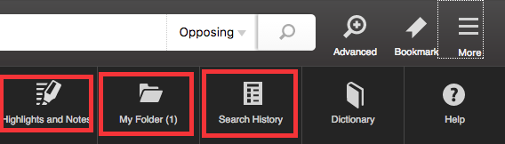

Step 16—Highlighting and adding notes. Highlight by holding down your LEFT mouse key and dragging it across the text, then click HIGHLIGHT.
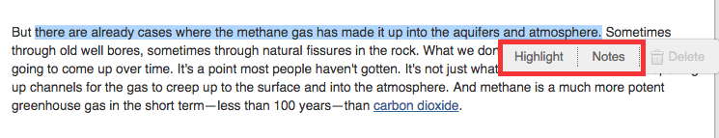

Step 17—Now choose the color of your highlight. The highlight remains until you click DELETE.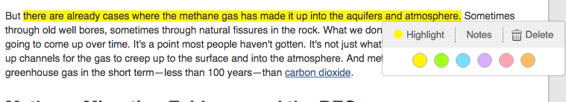

Step 18—Now click on NOTES for your highlighted text. Ask questions or comment on the material (can be shared with other people).

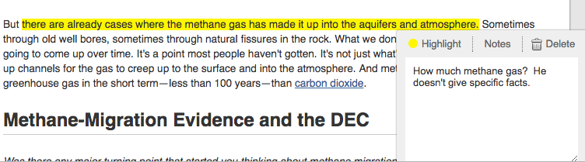

This has been an overview of the BASIC functions of this database. The GALE databases are all very similar so if you’ve learned how to search World History in Context, your skills should transfer over to those other databases.

Remember: Use databases BEFORE Google! Databases are written by experts and are VERY trustworthy. Websites found through a Google search actually take MORE time because you have to evaluate each website and you have to search through a lot more results to get the information you need. So: Save time! Be accurate! Use a database!

