QUICK GUIDE
BIOGRAPHY IN CONTEXT

Follow this guide step-by-step and you’ll have mastered the basics of all the Gale databases (they all use the same tools and search functions).

Want to jump directly to the library webpage? Use the free QR Code Scanner app in your phone to jump to it:

Step 1—START. Go to www.bhhslibrary.com, then Research&Tools—databases.
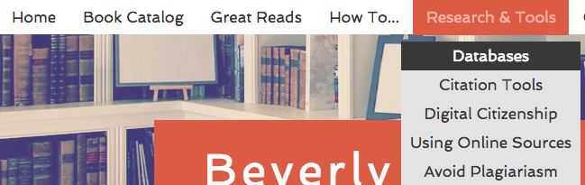

Step 2—Click on the Biography in Context icon. You only need the username and password if you are NOT on the BHHS campus.

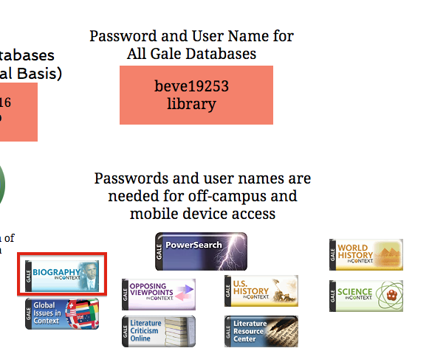

Step 3—SIGN IN. Open a separate tab and sign into your Gmail account (personal or school account). THEN click “Sign in…” to create a free online account. You’ll need this!
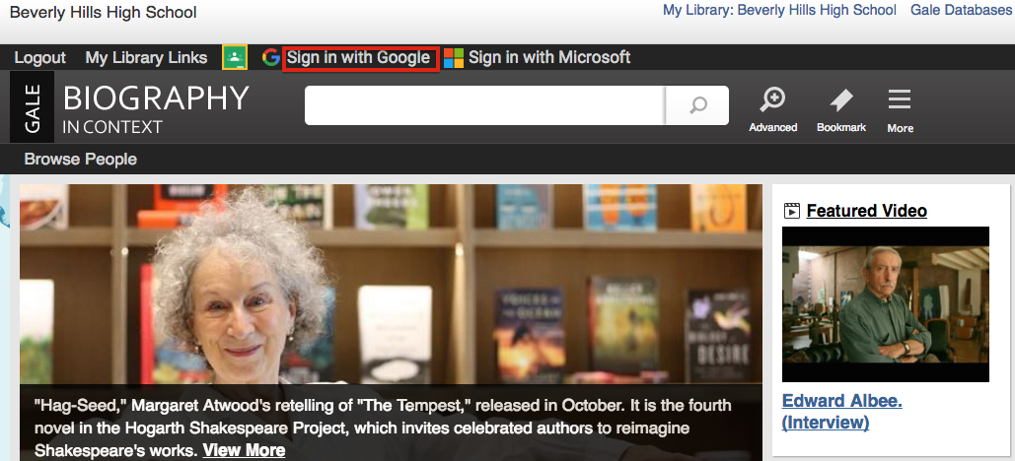

Step 4—You can tell you’re signed in when your first name appears at the top of the screen.

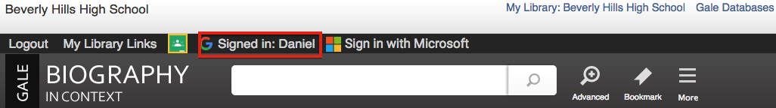
Step 5—Click on MORE and you’ll see some cool functions in the dropdown menu. Let’s look at “highlights and notes” and “my folder”—both useful for organizing your work!

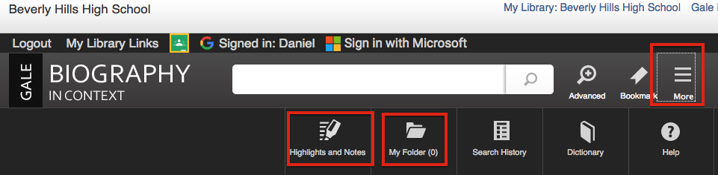
Step 6—Need ideas for research? Pick a category to see what’s available (choose Writers for this example).
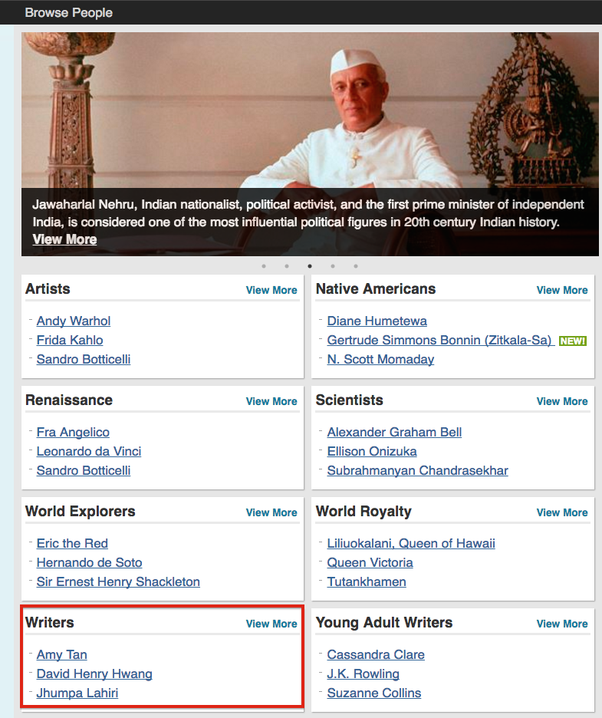

Step 7—Any name on this list is GUARANTEED to have enough information to do a research paper—a real time-saver when doing research!!!

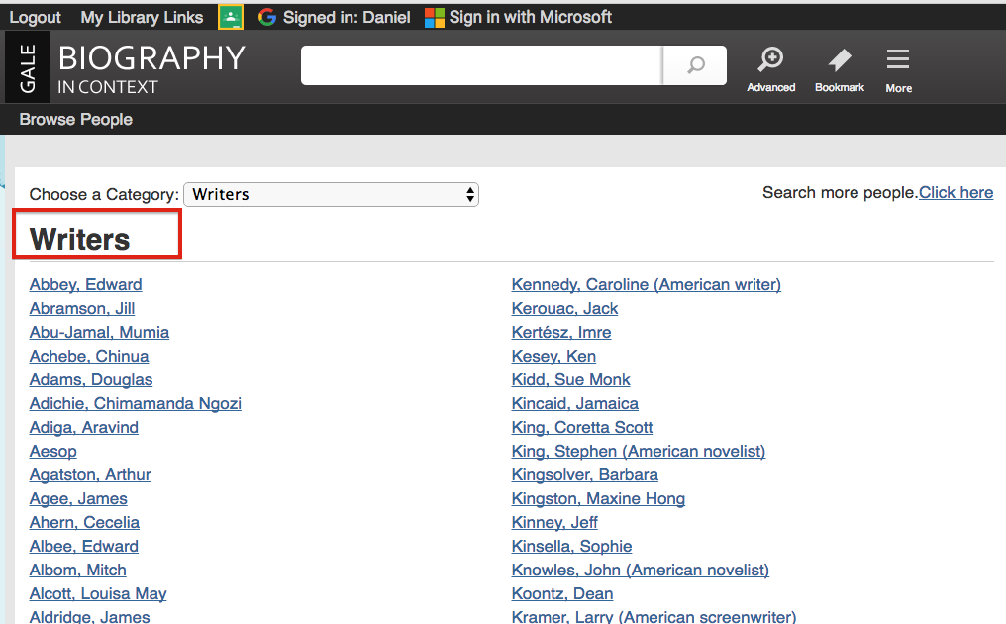

Step 8—If you already know the name of the person you want to research, just type it in the search bar at the top. The database will suggest search terms when you start typing in the search bar. The MAIN ENTRY for this person will appear in boldface. Click on that!
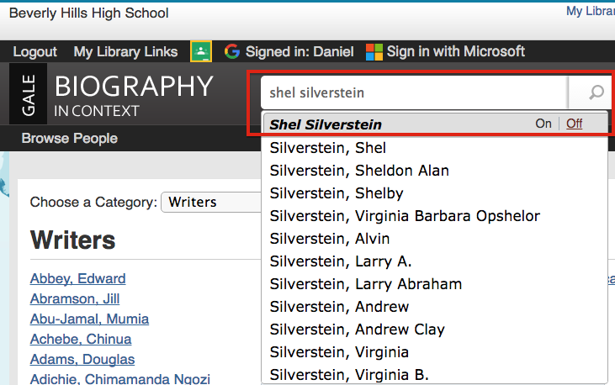

Step 9—On This Page shows you everything available about Shel Silverstein! Click on View More to see the main entry.
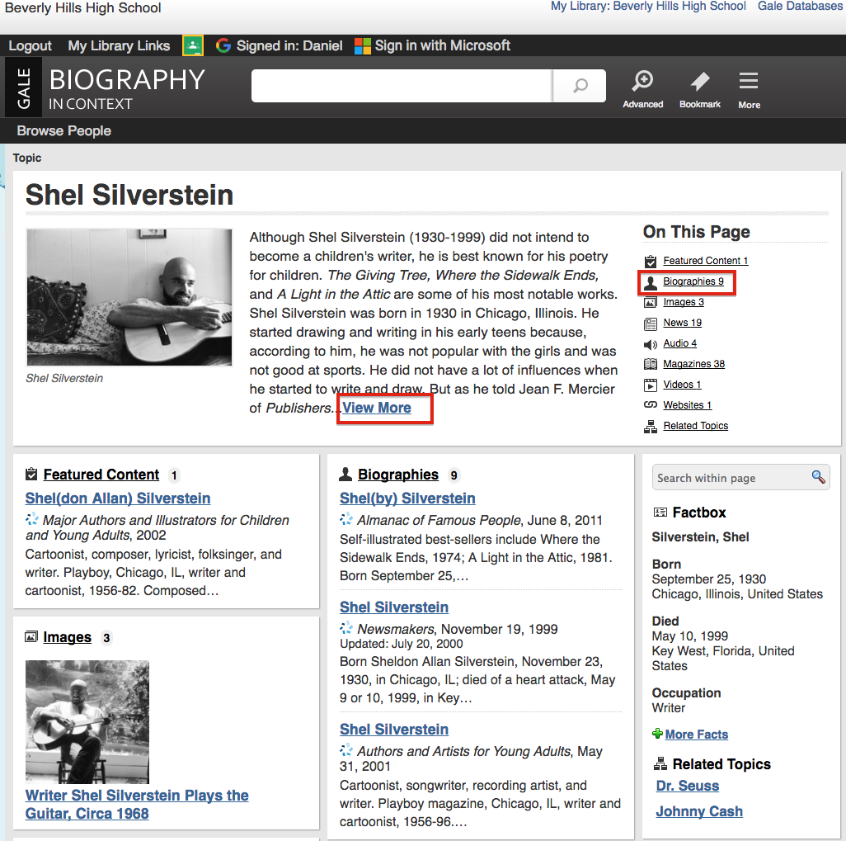

Step 10—The entry shows the SOURCE and also has an option to have the text read to you!

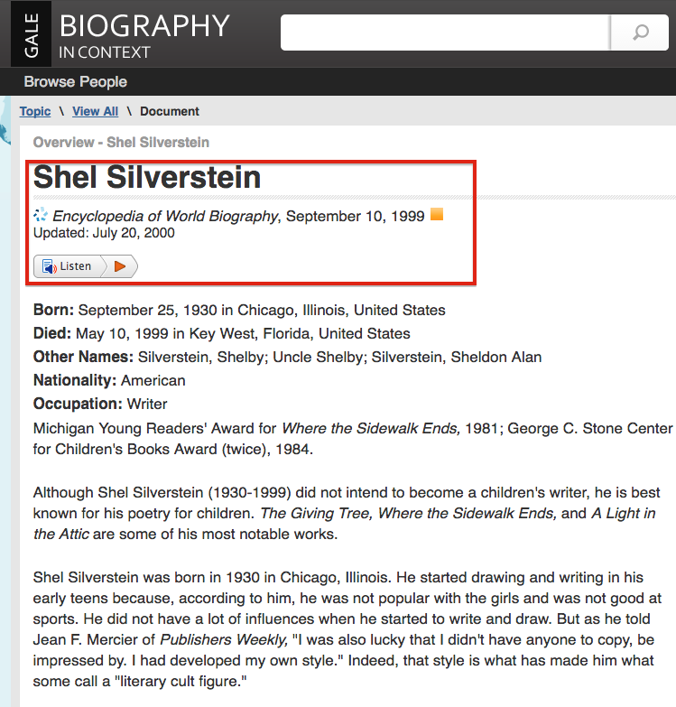

Step 11—Let’s use some of the TOOLS (menu on the far-right side of the page) to see how they can help us do our work faster and more accurately! We’ll start with Citation Tools.

Click here to automatically cite your article!

Use this to email your article to yourself or others!

Click here to download in PDF or to SAVE to GOOGLE DRIVE

Click here to add highlighting and/or notes

Click here to SAVE to your online account. The articles will disappear when you log off, so download them to Google Drive.
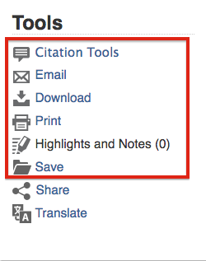

Step 12—You have 4 options for Citation Tools. You don’t have to worry about citing your sources: the database does it for you! You can also save it to Google Drive!

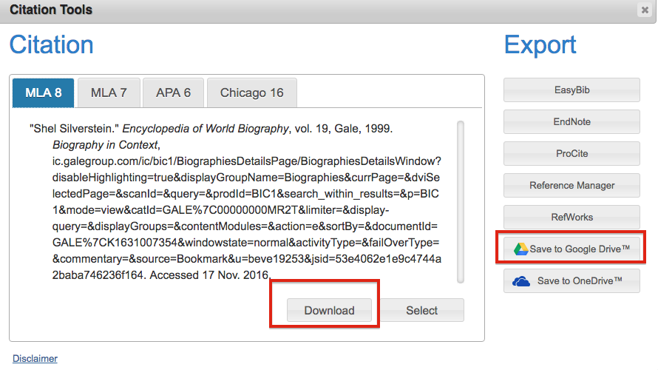

Step 13—EMAIL: There’s an EMAIL button in the menu. Click on it and fill in the blanks to send the article to yourself, a teacher, or your work partners. Send as an html link or as a PDF document.

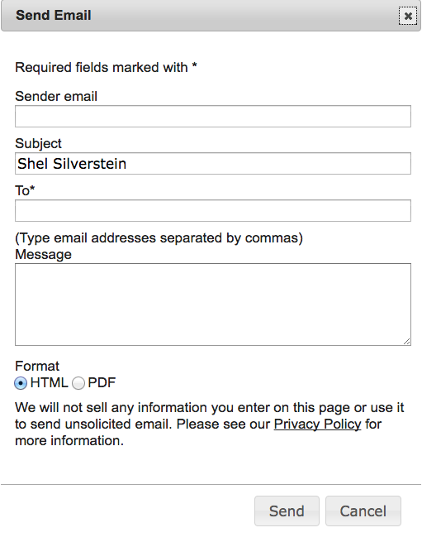

Step 14—DOWNLOAD: Download = Save to Google Drive. ALWAYS do this so you can have easy access AND easily share with other people!
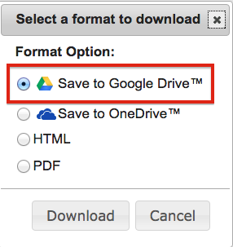

Step 15—HIGHLIGHT/NOTES: You can highlight and take notes on key parts of an article. Just hold down the LEFT button your mouse and drag it across the text you want to highlight, then click “Highlight” and/or “Notes”. The highlight remains until you click DELETE.

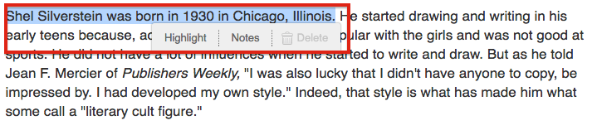

Step 16—When you do this, the Tools will show how many highlights or notes you have. You can go directly to them by clicking on “Highlights and Notes”.
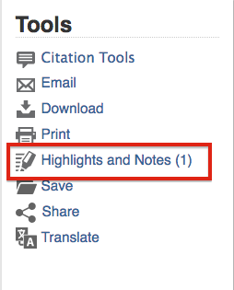

Step 17— SAVE: When you click on the SAVE button in the menu, the article will show up as added in “My Folder”. Click on “My Folder” to see all the articles you saved. WARNING: The articles DISAPPEAR from “My Folder” when you log off, so make sure you save them to Google Drive.
(Review all of your searches by clicking on Search History.)

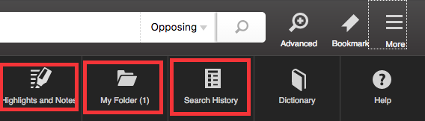

Step 18—Click on MY FOLDER. You can save ALL of them to Google Drive or email all of them at one time by putting a check mark next to the article and then using the Tools. You can also remove ALL of them at one time.
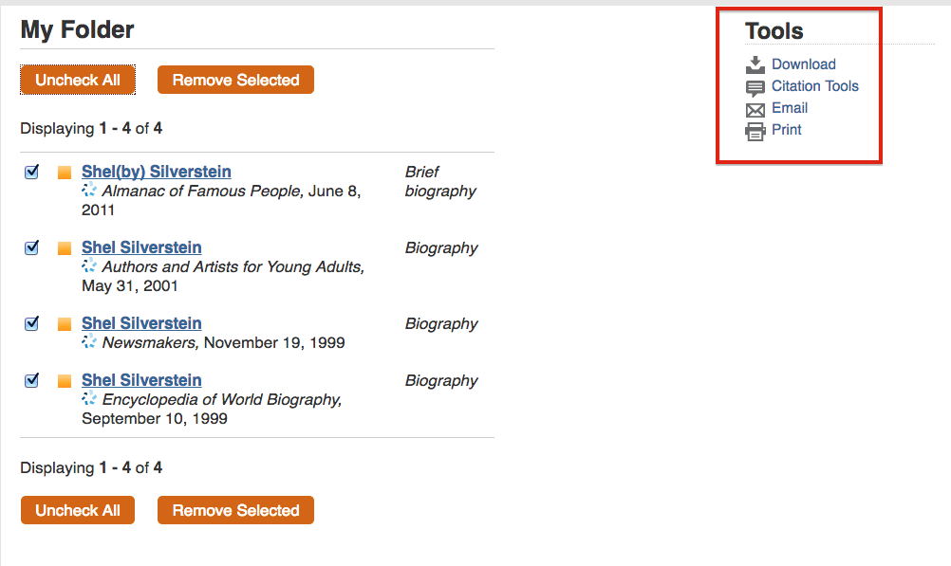
When you click “Download”, choose the “Save to Google Drive” option (See separate quick guide on how to organize files in Google Drive):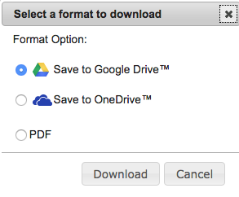

Step 19—WAIT! I saved the best part for last! The Gale databases ALL use the SAME Tools and search functions. By learning this database, you’ve learned how to use ALL of them! That’s NINE databases!
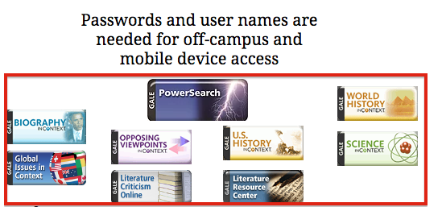

Remember: Use databases BEFORE using Google! Databases are written by experts and are VERY trustworthy. Websites found through a Google search actually take MORE time because you have to evaluate each website and you have to search through a lot more results to get the information you need.
Save time! Be accurate! Use a database!

