RESEARCH GUIDE FOR EBSCOHOST DATABASE SEARCH

WHAT IS EBSCOHOST?

EBSCOHOST actually searches more than 25 multi-disciplinary databases all at once. It’s a good choice to begin your research!

SEARCH STRATEGY

Step 1

Start with BHHSLIBRARY.COM.

Go to the EBSCOHost link. Since this is a TRIAL subscription, you have to complete some extra steps (see screenshots below):

Choose DATABASES
THEN click on the EBSCOHOST link

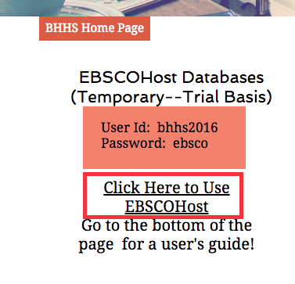
THEN enter the username and password

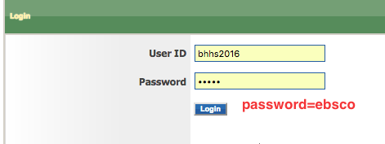

You can use ANY of these databases but to start, scroll down and choose the one outlined in red:
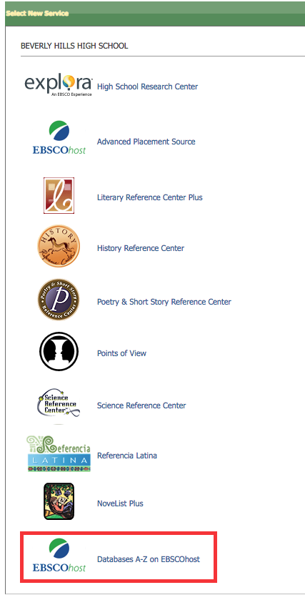

THEN—scroll down to the bottom of the page and choose TOPICsearch
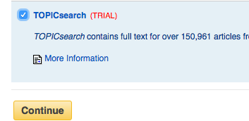

Your screen should look like this!

Step 2

Create an account. This will save your search history and you can also save your research in a folder that you can access from any computer!

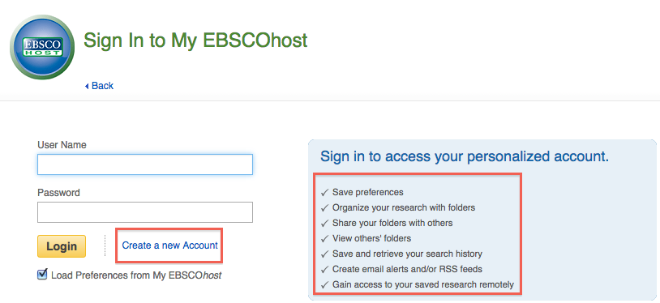

Step 3

Click on ADVANCED SEARCH on the home page.

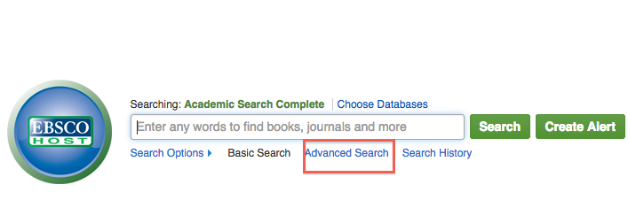

Step 4

Enter the search terms student loan debt in the first search field. Check the FULL TEXT search box then SEARCH.

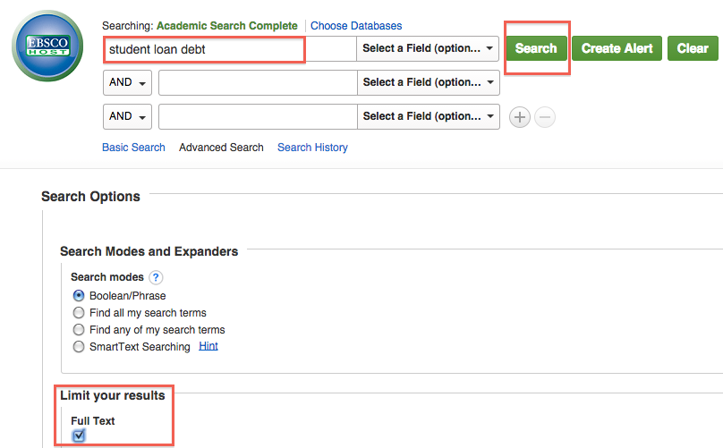

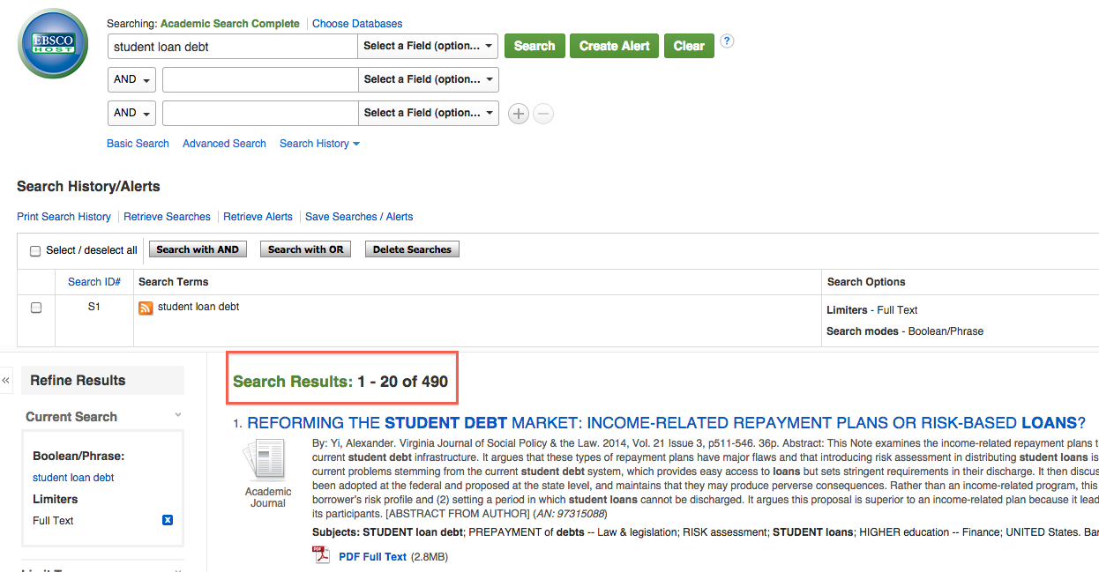

Step 5

Change view to “detailed”
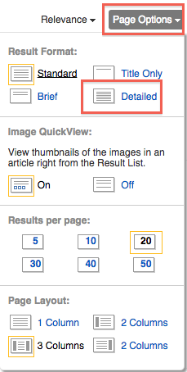

Don’t forget to use Boolean Operators!
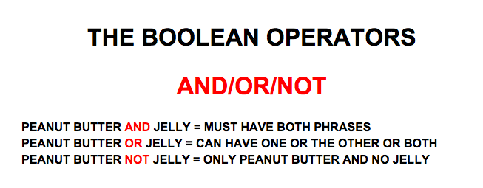

Add an AND search by typing crisis in the second search field. SEARCH.
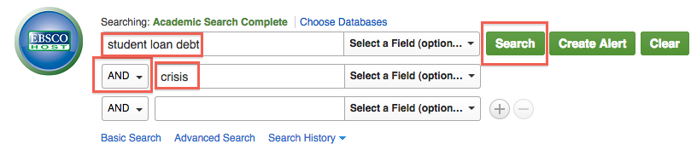

Step 6

Run the first search by clicking on SEARCH HISTORY.
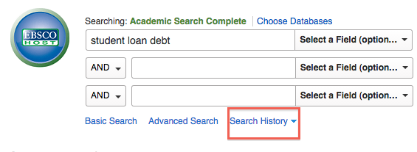

Choose the first search, S1 (student loan debt)
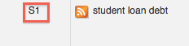

Click on VIEW RESULTS to run the search again.

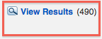
Step 7

Narrow your search by changing the date range. Type 2009 in the date box to the left.

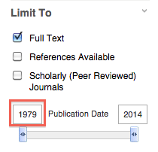
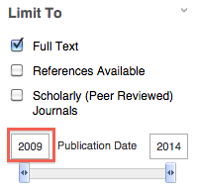

Search will now be for articles from 2009-2014 only.

Step 8

Now limit to SCHOLARLY PEER-REVIEWED articles only.

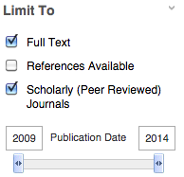
Step 9

Click on the link to the article “Reforming the Student Market….”

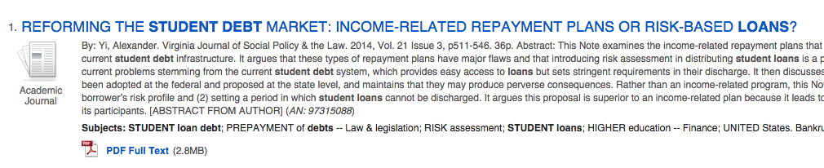

Step 10

Use the toolbar to the left to CITE the article, EMAIL it, ADD it to your folder. MAKE SURE YOU ARE SIGNED IN BEFORE ADDING IT TO THE FOLDER!
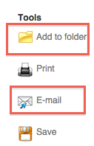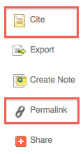

Step 11

Click on the PDF full-text link to see the full article.

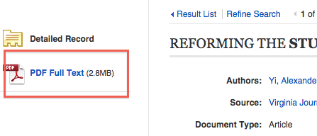
Step 12

Advanced Searching Techniques

Boolean Operators: AND/OR/NOT
Date limiters
Article limiters
EXACT PHRASE SEARCHING: Quotation marks will force a search for that exact phrase.
Examples: “Barack Obama”
“cell phone”
“peanut butter”
TRUNCATION SEARCHING: Typing an asterisk at the ROOT of a word will search for all variations of that word.
Example: creat*
Will retrieve entries for all documents containing the words: creature, creation, create, creating, creator, etc.
child* = child, childs, children, childrens, childhood
genetic* = genetic, genetics, genetically
WILDCARD SEARCHING: Typing a ! in place of a letter searches all variations.
Example: wom!n
Will retrieve entries for “woman” and “women” and “womyn”

